Exercises – Semantic Tableaux Method

Using the semantic tableaux method decide what kind (consistent, inconsistent, valid) of formula is 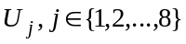.
If is consistent, find all its models.
- ;
- 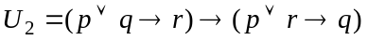;
- 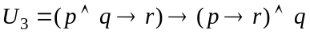;
- 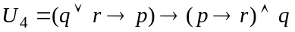;
- ;
- ;
- 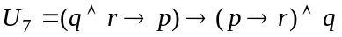;
- .

Prove that the following formulas are tautologies using the semantic tableaux method:
- distribution of ’’ over ’’: ;
- separation of the premises law: 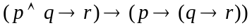;
- distribution of ’’ over ’’: ;
- distribution of ’’ over ’’: ;
- reunion of the premises law: 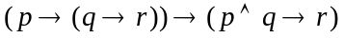;
- distribution of implication:;
- distribution of ’’ over ’’: .
- permutation of the premises law: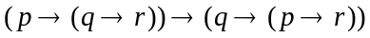;

Using the semantic tableaux method, decide whether the following logical consequences hold or not.
If a logical consequence does not hold find an anti-model of it.
- 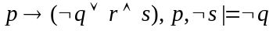
- 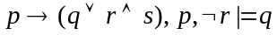
- 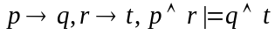
- 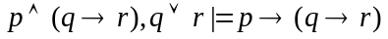
- 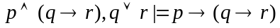
- 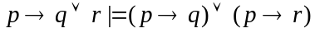

Write all the anti-models of the propositional formulas 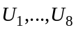 using the semantic tableaux method.
- 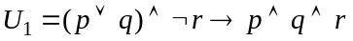;
- 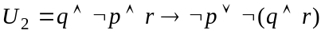;
- 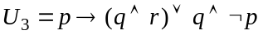;
- 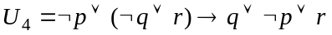;
- 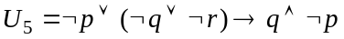;
- 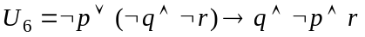;
- 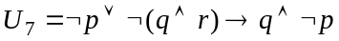;
- .

Using the semantic tableaux method, prove the following properties in predicate logic:
- ’’ is semi-distributive over ’’:
and

- ’’ is semi-distributive over ’’:
and

- ’’ is semi-distributive over ’’:
and

- ’’ is semi-distributive over ’’ :
and

- and
- ’’ is distributive over ’’

- ’’ is distributive over ’’

Check the validity of the following first-order formulas using the semantic tableaux method:
- ;
- ;
- ;
- ;
- ;
- ;
- ;
- .

Using the semantic tableaux method check whether the following logical consequences hold.
- ;
- ;
- ;
- ;
- ;
- ;
- .

